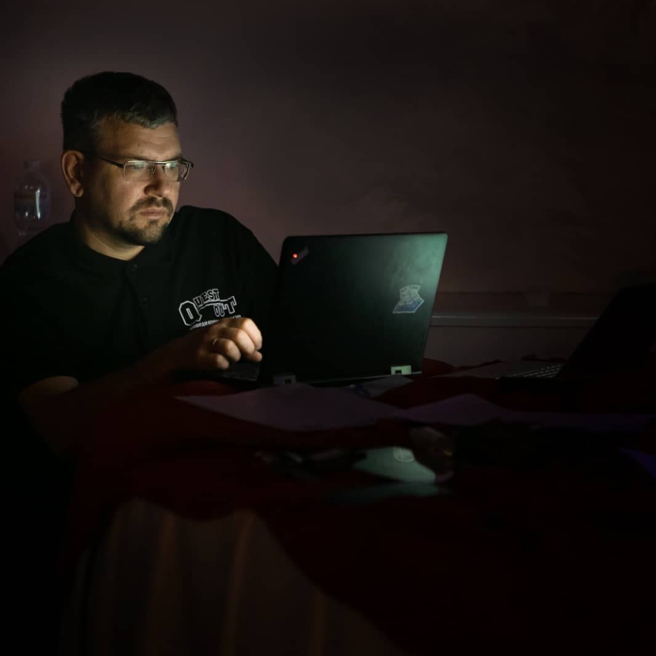

**Contacts:**

<https://www.linkedin.com/in/mikhail-salikhanov/>

mikhail.salikhanov@gmail.com

+380672818987

**Skills:**

Front End (HTML, CSS, JS)

**Languages**

English (Professional Working)

Ukrainian (Native or Bilingual)

Russian (Native or Bilingual)

Polish (Limited Working)

Mykhailo Salikhanov

Junior/ Trainee Front End Developer

Ukraine

Work experience

Since February 2022 I have been having a career break for professional development due to the war in Ukraine. I am recollecting my English and programming skills (I used to work in IT as a student).

**Quest Out Events**

Event manager and Head of Quest Out Events

March 2018 - February 2022 (4 years) Kryvyi Rih. Ukraine

Major responsibilities:

Organization of events for the largest enterprises in Kryvyi Rih: Metinvest (certified event services provider), ArcelorMittal, PrivatBank, UkrSibBank, etc.

Organization and promotion of the Quiz Out project (350+ players for every game)

**ArcelorMittal Kryviy Rih**

11 years 4 months Kryviy Rih, Ukraine

Quality Transformation Manager

August 2013 - March 2018

Major responsibilities:

Driving the transformation of the company's quality department and improving the efficiency of the quality service.

CAP Auditor of Internal Assurance Department

January 2012 - July 2013

Major responsibilities:

► Reviewing financial, operational and administrative controls system;

►Assessing the adequacy and efficiency of internal controls;

► Preparing work papers

► Developing recommendations aimed to eliminate observations revealed, which enable to reduce risks of specific transactions or minimize potential losses;

►Preparing draft reports containing observations and recommendations

Section Chief of Quality Department

August 2010 - January 2012

Major responsibilities:

Assessment of product compliance with the documentation requirements and analysis of the causes of the nonconforming steel production.

Senior inspector of the steelmaking processes

April 2008 - August 2010

Major responsibilities:

Engineering Controls of steel smelting and casting processes in the BOF shop

Inspector of the steelmaking processes

September 2007 - April 2008

Major responsibilities:

Engineering Controls of steel smelting and casting processes in the BOF shop

Processing engineer of the Metal Science Laboratory

December 2006 - September 2007

Major responsibilities: Investigation of metal structures and properties

**PJSC "Resonance"**

June 2005 - October 2005, Kryvyi Rih. Ukraine

Trainee: C++, Front End

Major responsibilities: software development for cash registers

Education

The National Metallurgical Academy of Ukraine

Specialist, Specialist of metallurgy (ferrous metallurgy) · (2001 - 2006)

Courses

* Frontend Fundamentals (2022)
* 4 Core Leadership and Management Skills (CLMS) training sessions delivered by TMA World (Cross Cultural Competence; Negotiation Skills; Effective Presentations and Speaking in Public; Dealing with Change) in ArcelorMittal Academy in Luxembourg (2012)
* Audit in SAP environment - Procurement cycle by ArcelorMittal Academy (2012)
* Financial Accounting Basics training in ArcelorMittal Kryviy Rih (2012)
* Industrial training and acquisition of theoretical and practical skill working continuous casting machine (CCM) in ArcelorMittal Poland S.A. (2011)
* Internal Assurance Methodology training in ArcelorMittal Academy in Luxembourg (2012)
* Seminar “Internal control of purchases” by PwC Ukraine (2012)
* Training "Microsoft Office Excel 2007" - Advanced Level